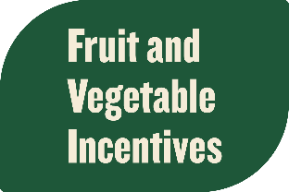

GusNIP Week of Action Toolkit

As important work on the Farm Bill continues, the ANNI Coalition is planning a Week of Action during November 6-10 to build on the momentum we have generated to encourage lawmakers to expand and improve GusNIP. There is broad and bipartisan support to grow GusNIP in the Farm Bill and Congress can take action to help the program reach its full potential.

Throughout the week and beyond, we encourage your organizations to share compelling stories in support of GusNIP. Please use the resources in this toolkit to help us demonstrate how GusNIP is a proven approach that benefits families, improves public health, and generates returns for farmers and economies.

Table of Contents
Messaging Resources 1
Sample Social Media Posts 1
Graphics 4
Template Constituent Letter 8
Template Letters to the Editor: 9
Op-Ed Outline 10

Messaging Resources
- GusNIP One-pager
- GusNIP Farm Bill Talking Points

Sample Social Media Posts

Twitter

- Congress has a big opportunity in the #FarmBill to help families bring home more fruits and vegetables. @SenateAgDems @SenateAgGOP @HouseAgGOP @HouseAgDems: Take action to expand and improve GusNIP!

- #ICYMI: GusNIP has broad and bipartisan support. Proposals from @maziehirono @RepDanKildee @RepRickCrawford @SenBooker & @RepLBR can be folded into the #FarmBill to make #FruitVegIncentives work better for farmers and families.

- 📢 Over 600 farm, food, & health leaders support GusNIP changes to expand and improve #FruitVegIncentives + #ProduceRx in the #FarmBill:
🌱 Increase funding
✖️ Reduce the match
🍽️ Scale incentives statewide
🩺 Improve produce prescriptions

Learn more: https://fruitvegincentives.org/

- #GusNIP helps farmers put more money in their pockets! In 2022, #FruitVegIncentives generated $85M for farmers and local economies. Congress can help farmers + families benefit by growing this proven program in the #FarmBill. https://fruitvegincentives.org/

- 🥕DYK: #FruitVegIncentives help people eat healthier? Growing #GusNIP in the #FarmBill can help more people afford fruits and vegetables so they can improve their health. https://bit.ly/3QA3p9l

- #FruitVegIncentives & #ProduceRx are working to improve nutritious food access, help people lead healthier lives, and boost farm income. Congress: Take action to grow #GusNIP in the #FarmBill so we can help farmers + families!

- 🚨 @SenateAgDems Chairwoman @SenStabenow wants to secure additional #FarmBill funding to help both farmers & families. Boosting #GusNIP will do just that. Congress: help #FruitVegIncentives reach their full potential.

Facebook

- As Congress works on the next #FarmBill, they have the chance to help families eat healthier while also benefiting farmers and local economies. The Gus Schumacher Nutrition Incentive Program aka #GusNIP increases families’ purchase power so they can get more bang for their buck when they buy fruits and vegetables using their SNAP benefits. It also means farmers and food retailers are making more sales, creating a major economic ripple effect.

Congress: Let’s grow GusNIP so that it can reach more communities and help local food economies flourish.

- #ICYMI: There is broad and bipartisan support to grow #FruitVegIncentives that help families make their nutrition assistance benefits go further when they buy healthy food. Bipartisan legislation has been introduced on both sides of the aisle to provide people with more purchasing power to add more fruits and vegetables to their diet and boost farmers’ bottom lines.

Congress: Grow GusNIP in the Farm Bill so that it can help more communities.

- Fruit and vegetable incentive programs like [State Incentive Program Name] are working, but they need more federal support if we want to see them grow and help more farmers and families alike.
Fortunately, there is strong bipartisan and bicameral support to grow the win-win Gus Schumacher Nutrition Incentive Program aka #GusNIP in the upcoming Farm Bill. Every dollar invested in GusNIP bolsters local food retailers and the agricultural economy while putting healthier food within reach for low-income families.

Learn more about GusNIP at https://fruitvegincentives.org/

- #FruitVegIncentives & #ProduceRx are working to improve nutritious food access, help people lead healthier lives, and boost farm income. [Name of your organization] joins over 600 health and food groups in calling on Congress to grow federal support for these essential approaches by expanding and improving GusNIP in the upcoming Farm Bill. Congress can take action by:

🌱 Increasing GusNIP funding
✖️ Reducing the match
🍽️ Scaling incentives statewide
🩺 Improving produce prescriptions

Learn more about GusNIP at https://fruitvegincentives.org/

- 🚨 Senate Agriculture Committee Chairwoman @SenatorStabenow recently committed to secure additional #FarmBill funding to help both farmers & families. The best way to do that? Boosting the successful Gus Schumacher Nutrition Incentive Program, aka GusNIP, which invests in local nutrition incentive initiatives and produce prescriptions that help families bring home more fruits and vegetables. In turn, farmers and local food retailers benefit from more sales.

Committing more funding to GusNIP will help these proven programs reach more families and farmers alike.

Graphics
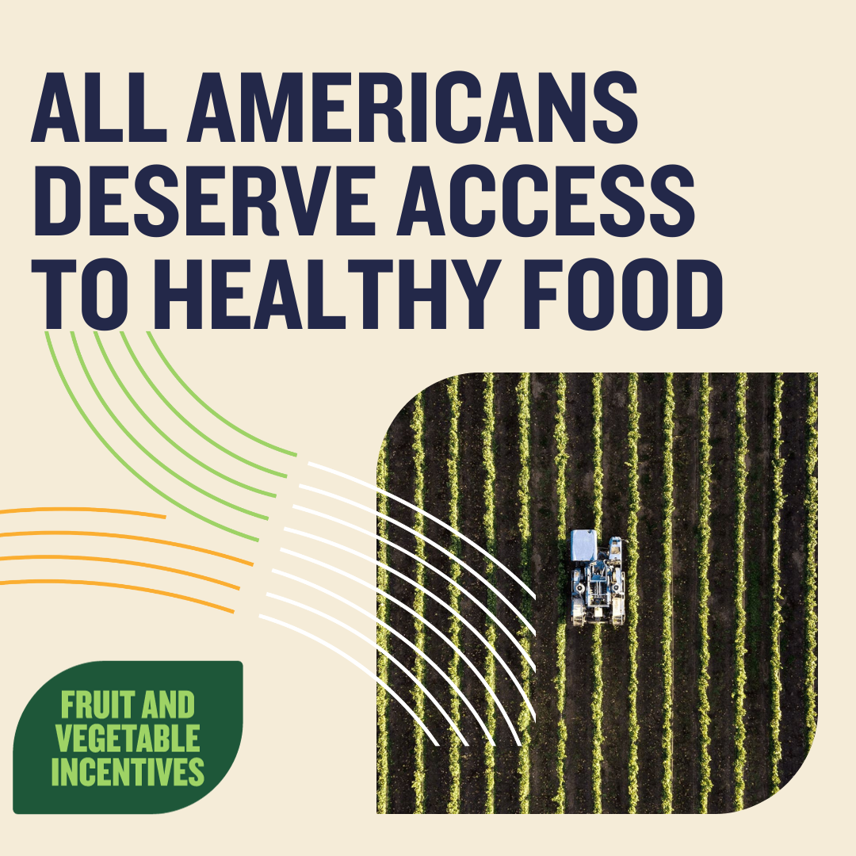
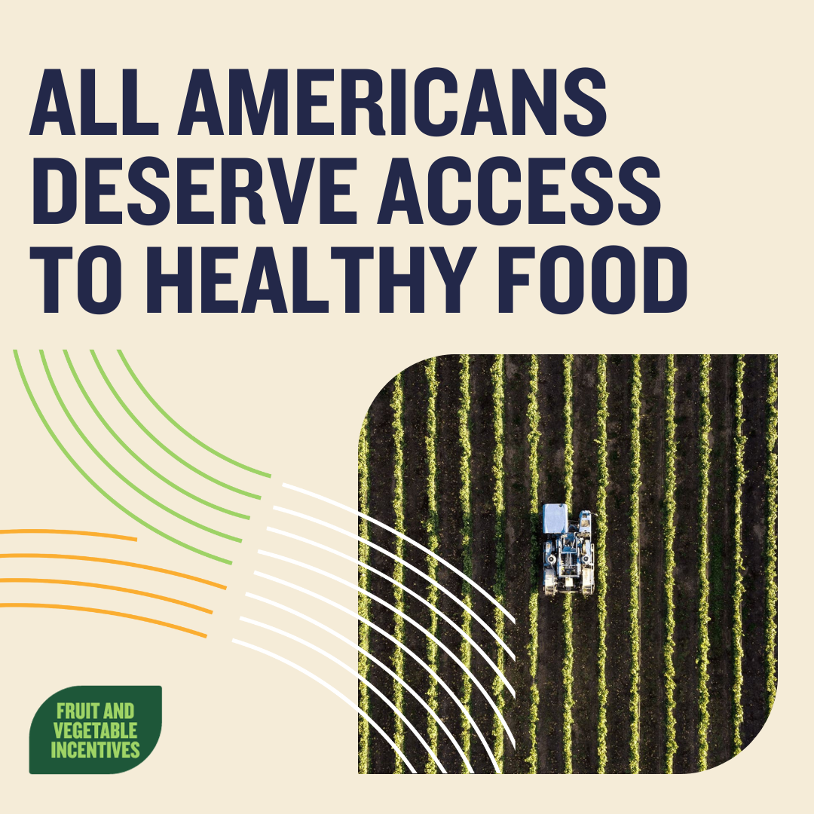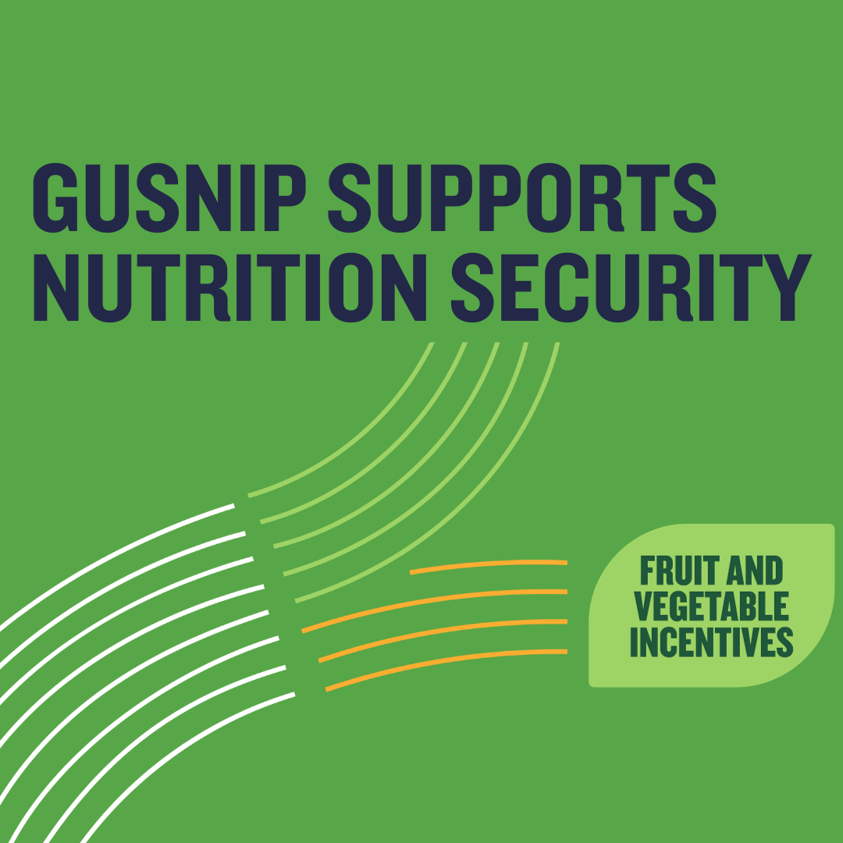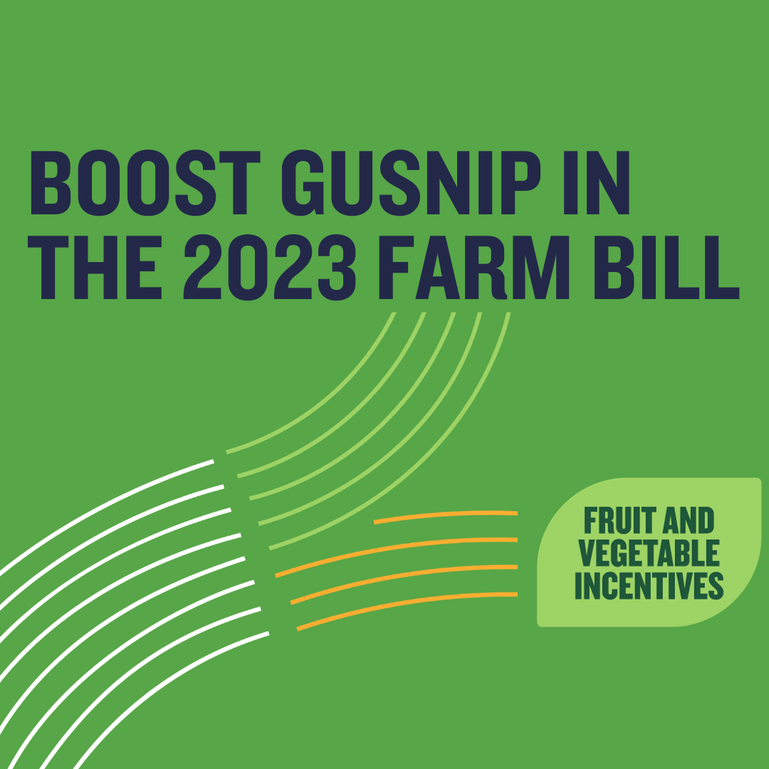

Template Constituent Letter

To encourage Members of Congress to support changes to strengthen nutrition incentives and produce prescriptions in the upcoming Farm Bill, please customize the template letter below and send it to your representative in Congress. You can send this letter in the mail, via email, or use it as a script for a phone call.

Contact information for U.S. House of Representatives: https://www.house.gov/representatives/find-your-representative

Contact information for U.S. Senators: https://www.senate.gov/senators/senators-contact.htm

[DATE]

The Honorable [First Name] [Last Name]
United States [Branch of Congress]
Washington, DC 20510

Dear [Title and Last Name],

As your constituent and a [business owner, grocer, farmer, food advocate, etc.], I strongly support improving and expanding the Gus Schumacher Nutrition Incentive Program (GusNIP) in the upcoming Farm Bill. GusNIP is a successful public private partnership that invests in nutrition incentives and produce prescriptions, which have expanded healthy food options for families and sparked economic opportunities for farmers and communities in our state.

[Provide any personal details about why GusNIP is important to you/your community]

There is broad and bipartisan momentum to grow GusNIP in the Farm Bill. Over 600 farm, food, and health leaders support changes in the Farm Bill, and there are several commonsense pieces of legislation that can be incorporated to help nutrition incentives and produce prescriptions benefit more farmers and families. As lawmakers come together to negotiate the upcoming Farm Bill, I urge you to cosponsor the OH SNAP Act, the GusNIP Expansion Act, and the GusNIP Improvement Act.

Sincerely,

[Signature]

[Printed name]

Template Letters to the Editor:
Letters to the Editor are written to the editor of a newspaper, often as a response to a recent article or news topic of interest to the publication’s readers and community. Letters are preferably between 150- 250 words, concise, and offer an opinion on the subject. Please be sure to check the publication’s specific submission standards, word limits, and guidelines before submitting as they vary from publication to publication.

Some publications prefer that letters be written in response to a specific article they have recently published, so we suggest keeping an eye out for articles about food access, hunger, nutrition, healthy eating, local food systems, or the Farm Bill. If responding to an article, you should reference the headline of the article in the opening line of your letter and try to submit it within 72 hours of the piece's publication. The sooner you send your submission, the more likely it is to get published.

If there hasn’t been any recent relevant coverage, many publications will still consider letters written about a topic of interest, especially if it is an issue of local concern, penned by a local author, and affects the community at large.
---
Congress Can Help Boost Farmers’ Income while Helping [STATE] Families Eat Healthier

Right now, Congress has a big opportunity to expand access to healthy food for families in [STATE], improve public health, and generate big returns for farmers and local economies. The Gus Schumacher Nutrition Incentive Program in the federal Farm Bill can do all three, but only if our lawmakers take action.

This program has gone to work for our state by investing in [State Incentive Program Name], which helps people or families who buy their groceries using the Supplemental Nutrition Assistance Program (SNAP) to match their purchases of fruits and vegetables. Here’s how it works: when a program participant buys $1 worth of produce with their SNAP dollars, they earn $1 in return to buy more fruits and vegetables. They can use their SNAP benefits towards bringing home more healthy food – it also means farmers and food retailers are making more sales, which creates a significant economic ripple effect. In 2022 alone, these programs generated an impact of approximately $85 million.

It’s a program that works. Families who participate in nutrition incentive programs are eating more nutritious food. A recent analysis shows that people who utilize nutrition incentives eat more fruit and vegetables compared to the average American.

As Congress works to pass a new Farm Bill, [LAWMAKER’S NAME] can support changes to expand and improve the Gus Schumacher Nutrition Incentive Program so that it can reach more communities and help more farmers in [STATE/COMMUNITY].

---

[STATE’S] Members of Congress Can Help Both Families and Farmers in the Farm Bill

Too many families in [STATE/COMMUNITY] struggle to put enough food on the table--especially healthy food. Fortunately, Congress has an opportunity to improve healthy food access and support local farmers at the same time.

The Gus Schumacher Nutrition Incentive Program in the federal Farm Bill invests in local initiatives like [State Incentive Program Name], which provides a [dollar-for-dollar match/discount] when a [STATE DENONMYN (i.e. Floridian, Michigander, etc.)] uses their Supplemental Nutrition Assistance Program (SNAP) benefits to purchase produce at participating farmers markets and grocery stores. The program also supports Produce Prescriptions that allows healthcare providers to prescribe food as medicine to their patients. Through the program, healthcare providers provide patients with [vouchers] that can be used to buy fruits and vegetables.

This has helped [COMMUNITY NAME] families bring home more nutritious food so they can lead healthier lives. A recent analysis shows that people who participate in nutrition incentive programs eat more fruit and vegetables compared to the average American. At the same time, farmers are benefitting from more sales of the food they grow.

Right now, Congress is working to pass a new Farm Bill and [STATE/COMMUNITY’S] lawmakers can take action to expand and improve the Gus Schumacher Nutrition Incentive Program so that more food retailers in our state can offer incentives in their community. As a longstanding champion for [STATE/COMMUNITY’S] farmers and families, I encourage [LAWMAKER’S NAME] to support changes to grow the Gus Schumacher Nutrition Incentive Program so that it can reach its full potential.

Op-Ed Outline
Op-eds are written for the opinion section of a news outlet to provide a unique perspective on a topical issue that affects their readership. Op-eds are typically between 500-750 words, persuasive, and clearly communicate a unique opinion or argument on the topic. Please be sure to check the publication’s specific submission standards, word limits, and guidelines before submitting as they vary publication to publication.

Unlike a Letter to the Editor, op-eds often undergo more rigorous submission standards and publications publish less of them. Outlets often prefer op-eds from local authors with prominence or credibility who can give insight to complicated problems and present an original argument about their topic. The more original and localized your argument and thoughts are, the more likely your op-ed will be published.

It is important to note that op-eds can be subject to suggestions and changes by the opinion editor of the outlet of your choice.

Op-Ed Outline:

Paragraph 1: Introduction
- Start off the op-ed with a strong lead that demonstrates how nutrition incentives have benefitted your community and introduce the need to improve and expand GusNIP in the Farm Bill to help your community.
  - (e.g., Now more than ever, families in our community need access to healthy food OR another angle about how a lack of funding for nutrition incentives has made it challenging for incentives to meet the current demand.)

Paragraph 2: What is GusNIP/what does it look like in your state?
- Provide background information about what GusNIP is and how it has invested in successful nutrition incentives programs/produce prescriptions in your state.
- Segue into the story you briefed at the beginning and tie it to the “why” of GusNIP.
- Example paragraph:
The Gus Schumacher Nutrition Incentive Program (GusNIP) in the federal Farm Bill is a proven solution to improve healthy food access across [State] and help people who participate in GusNIP nutrition incentive programs eat more fruits and vegetables. Nutrition incentive programs have demonstrated successful public-private partnerships that have helped families using SNAP or produce prescriptions bring home more nutritious food and sparked economic opportunities for farmers and communities across the country.

In [State], GusNIP has [insert state specific data nutrition incentives and produce prescriptions have had on families’ health and communities’ economic growth.]

Paragraphs 3-5: What impact has GusNIP had in your state?
- Provide context for how GusNIP has long been considered a multi-win solution that is benefiting families, improving public health, and generating returns for farmers and economies:
- Example paragraph:
GusNIP has helped families living in under resourced communities access and afford more healthy food in our community. Roughly 90% of Americans do not eat the recommended amount of fruits and vegetables needed to maintain a healthy diet, which is particularly challenging for people with low income, who say their primary barrier to eating healthier is affording healthy food. A recent analysis shows that people who participate in nutrition incentive programs eat more fruit and vegetables compared to the average American, while improving their food security.

GusNIP is a transformative force in public health, enabling more Americans to access healthier food options that improve health outcomes. Produce prescriptions are helping to expand food as medicine, with impacts rivaling prescription therapies for heart health and offering new hope for improving diabetes.

It also generates a powerful ripple effect through local economies, benefiting farmers and businesses alike. The economic impact of GusNIP has been considerable, generating approximately $85 million in 2022, a 107% increase from the previous year.

Paragraphs 6-7: The opportunity and momentum to grow GusNIP in the Farm Bill
- Highlight how Congress can take action to help the program reach its full potential in the 2023 Farm Bill.
- Example paragraphs:
In order to ensure that nutrition incentives and produce prescriptions are able to reach more families and help more farmers in our state, Congress must take action in the upcoming Farm Bill to improve and expand GusNIP. Over 600 farm, food, and health leaders support changes to strengthen nutrition incentives, including a significant investment to expand the program across more food retailers and a reduction of burdensome matching requirements to enable more partners to participate.

Fortunately, we are seeing bipartisan ideas for how we can strengthen GusNIP so that it can reach more people. Lawmakers from both sides of the aisle and both sides of the Capitol have seen the potential to incorporate commonsense updates in the next Farm Bill that will help nutrition incentives and produce prescriptions benefit more farmers and families in our state. Legislation such as the GusNIP Improvement Act, GusNIP Expansion Act, and the Opt for Health with SNAP (OH SNAP) Act include important provisions that can be folded into the Farm Bill to make nutrition incentives and produce prescriptions work better for farmers, families, retailers, and local economies.

Conclusion and Call to Action:
- Finish strong with a specific ask. Consider tying this paragraph back to the anecdote you opened with.
- Example call to action:
As Congress works to pass a new Farm Bill, [STATE/COMMUNITY’S] lawmakers can take action to expand and improve GusNIP so that [more food retailers in our state can offer these initiatives to families in need.] [STATE/COMMUNITY] is fortunate to have [LAWMAKER’S NAME(S)], who [has/have] been [a] longstanding champion[s] for our farmers and families. I encourage [LAWMAKER(s)] to build on that legacy and support changes to grow GusNIP so that it can reach its full potential.

